ASSIGNMENT - 6 [09-12-2023]

By Karthikeyan K R

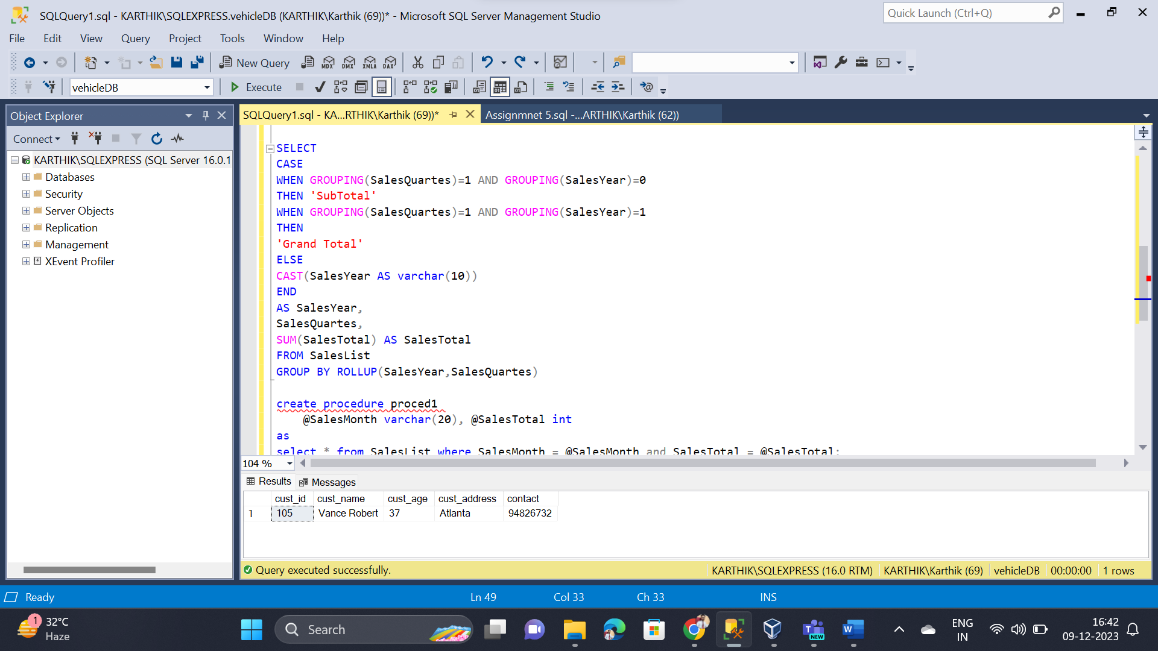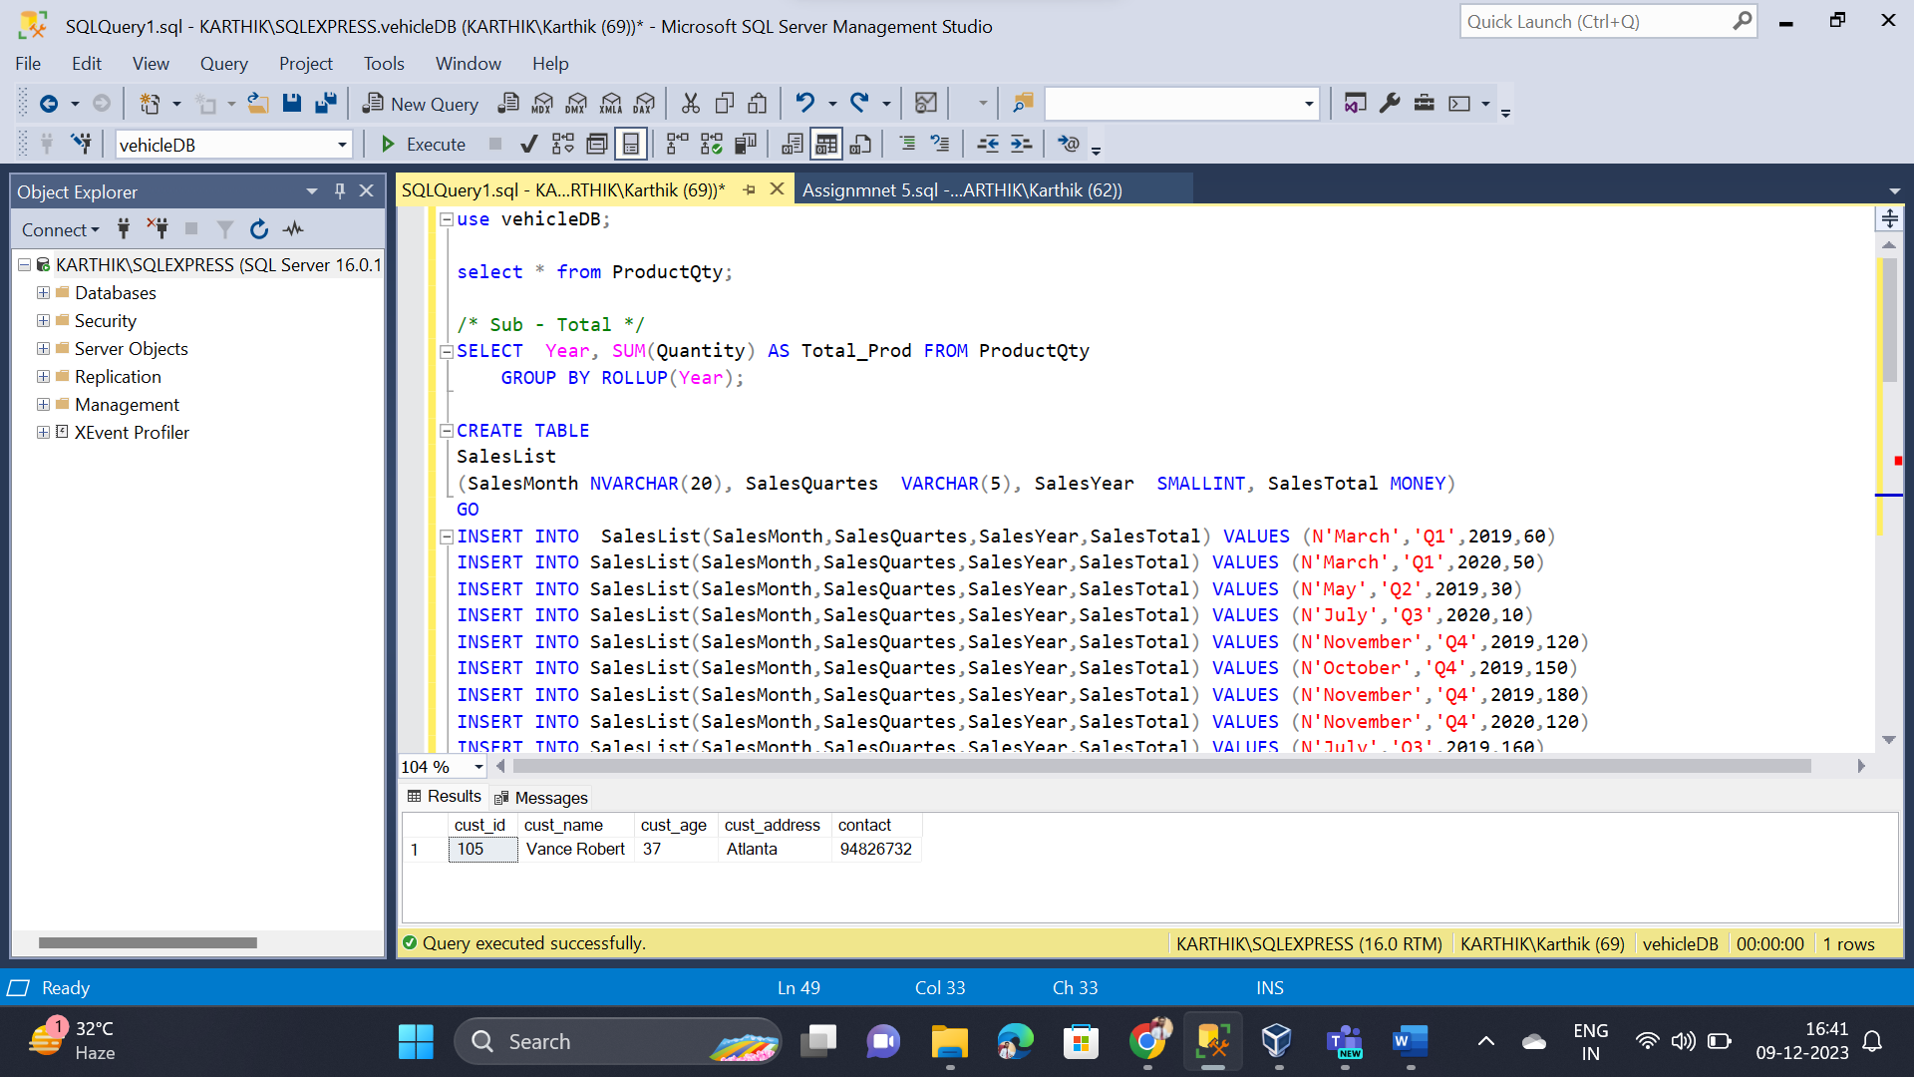

* 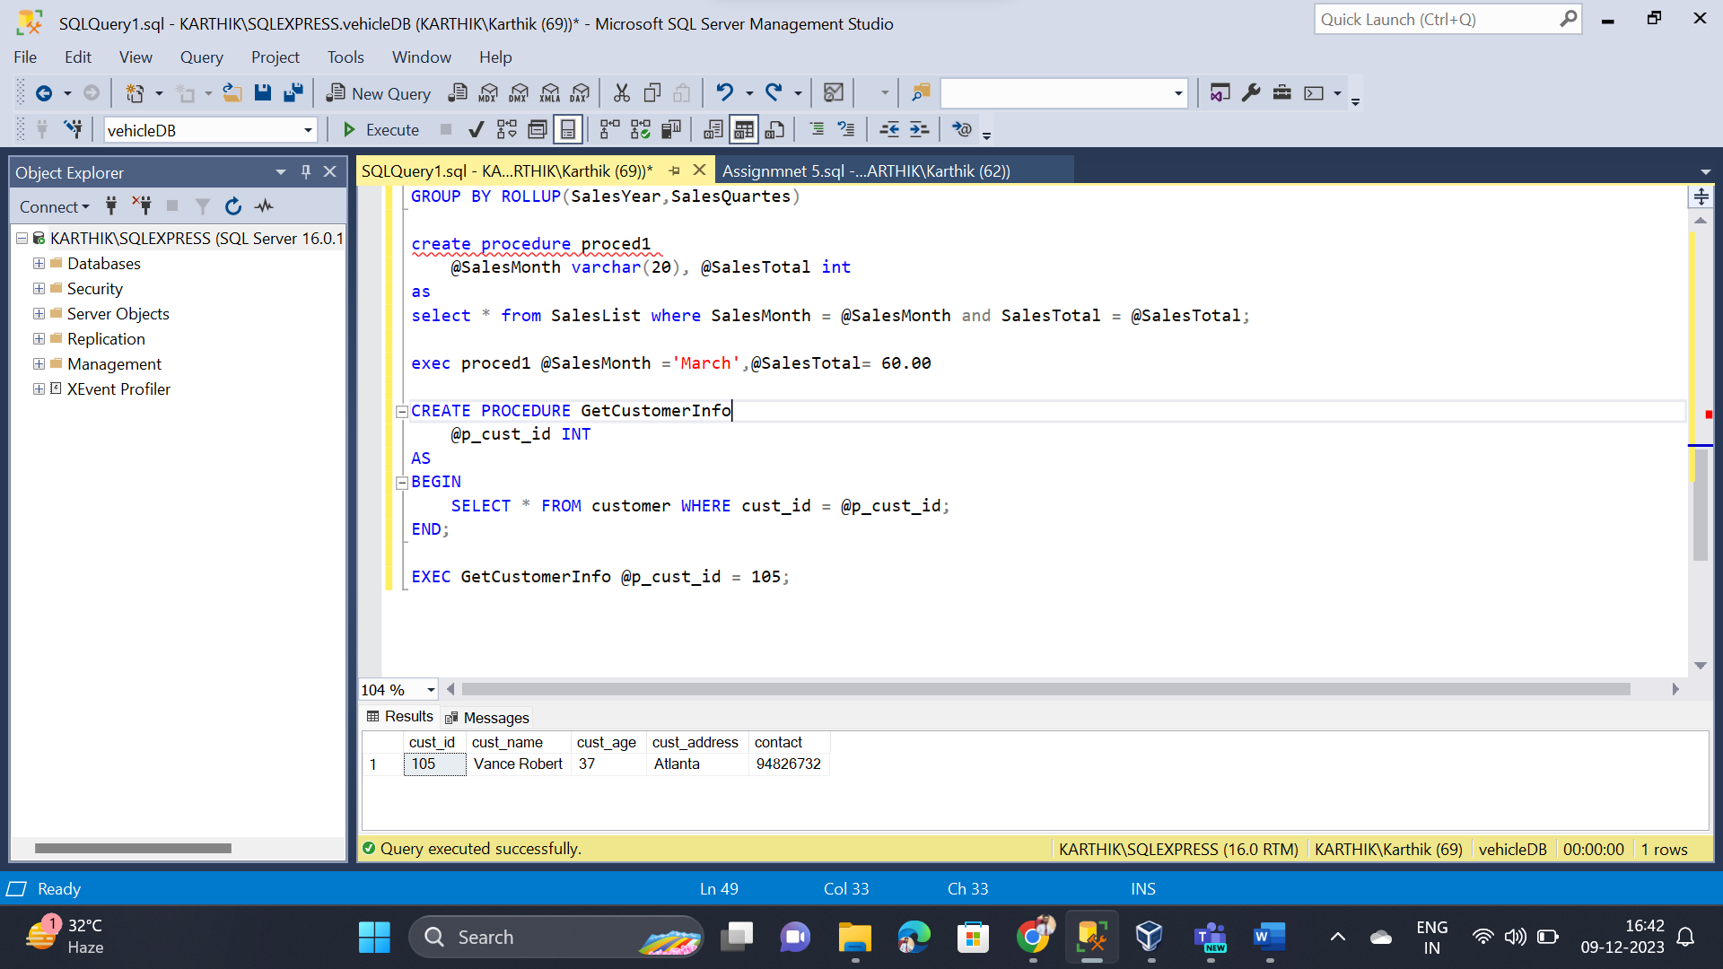Completed Sub-Queries
* Completed Stored Procedures